|  |  |
| --- | --- |
| To: | Committee of the Whole |
| Agenda Section:  Division: Department: | Corporate Services  Engineering, Planning and Environment  Planning |
| Item Number: | CCW - 16-312 |
| Meeting Date: | September 7, 2016 |
| Subject: | County of Simcoe Transit Feasibility and Implementation Study – Interim Report 3 and financial plan and implementation options |

**Recommendation**

**That Item CCW 16-312, dated September 7, 2016 regarding County of Simcoe Transit Feasibility and Implementation Study – Interim Report 3 and additional information outlining the financial plan and implementation details, be received; and**

**That phased implementation of the proposed short term service plan, as generally outlined in Item CCW 16-312, be approved; and**

**That Committee select a preferred funding option for 2017 budget consideration based on the options outlined in Item CCW 16-312.**

**Executive Summary**

This Item provides an update and estimated costing of a County wide transit service plan. Policy, at all levels, recognizes the need to support, establish and expand transportation options. The County has an opportunity to establish a co-ordinated strategy moving forward to ensure the continued health, safety and economic benefits of transit are realized throughout the County.

Direction has been given by Council to undertake a comprehensive study to identify the feasibility and implementation of a county-wide transit system and to establish a study Advisory Committee comprised of County staff, municipal representatives and agency stakeholders.

Further to the March 22, 2016 Council Transit Workshop, using data compiled from the Transit Feasibility and Implementation Study, staff have prepared additional information regarding service plan details and options with respect to service design and costing for Council’s consideration.

County staff, in consultation with Steer Davies Gleave initiated the Transit Feasibility and Implementation Study in January 2015. The study process is comprised of three interim reports.

Interim Report 3 (Schedule 1) provides information on the final phases of the study. Following the introduction in Chapter 1, Chapter 2 of Interim Report 3 provides a synopsis of the second round of consultation and feedback received from participants.

Chapter 3 outlines the service plan and prioritization for the services proposed to be implemented in the short term (five years). Interim Report 3 also summarizes in Chapter 4, the requirements for specialized transit arising from the *Accessibility for Ontarians with Disabilities Act* (AODA). The guiding principles behind a series of potential fare arrangements involving the County and other agencies’ services are identified in Chapter 5 as is the consultant’s recommended fare structure.

Funding sources and estimated fare revenues are identified in Chapter 6. Chapter 7 provides information regarding a financial and implementation plan for consideration of funding options, and outlines the recommended implementation plan proposed by Steer Davies Gleave. Detailed next steps required to implement transit, the proposed service network and implementation plan are identified in Chapter 7.

In addition, staff have prepared alternative financial and implementation plans for services proposed for the short term, based on a 10 year financial outlook, for Council’s consideration.

Staff is seeking Council direction for a preferred funding option as detailed within this Item for further consideration and ultimate inclusion within the 2017 budget.

**Background/Analysis/Options**

Since 2006 a series of studies such as the Intergovernmental Action Plan (IGAP) for Simcoe County, Barrie and Orillia, Implementation Assessment Report (August 2006), the County of Simcoe Transportation Master Plan 2008 (TMP), the County TMP Update 2014, and the Ministry of Transportation Simcoe Area Multimodal Transportation Strategy (2014) have identified theneed to reduce reliance on the automobile and increase alternate modes of transportation including improved linkages between regional and local networks for walking, cycling and public transit.

Furthermore, various policy documents such as the Growth Plan for the Greater Golden Horseshoe (Growth Plan), Provincial Policy Statement and the County of Simcoe Official Plan provide policies which strategically support growth and prioritize planning for complete communities and transit-supportive design. Additionally, the proposed Growth Plan for the Greater Golden Horseshoe, 2016 provides that public transit will be the first priority for transportation infrastructure planning and that all decisions on transit planning and investment support facilitating improved linkages betweenand within municipalities.

To support the proposed policy direction of the Growth Plan, the Ministry of Transportation (MTO) commenced a Greater Golden Horseshoe (GGH) Multimodal Transportation Plan in the spring of 2016 and it is anticipated to be completed in 2018. According to the MTO website, the GGH Multimodal Plan is intended to “inform policy and investment decisions that support the government’s commitments to climate change, economic development and innovative technology and provide direction to transportation agencies and service providers for all modes, including highways, railways, regional transit systems, cycling and walking”.

The Province continues to place significant emphasis in the requirement for multimodal transportation infrastructure, including regional transit systems, because it provides an alternative to driving and helps connect people to community services and job opportunities.

Benefits of Regional Transit Systems

A regional transit system is part of the comprehensive transportation strategy recommended in the County’s Transportation Master Plan to accommodate the County’s growing communities and changing demographics in the years to come. A well-planned transit system with supportive land uses is able to enhance mobility for residents, promote independent living, offer greater travel opportunities, expand economic opportunities, provide affordable transportation options, and support County growth, transport, and environmental policies.

Integrated public transportation infrastructure also allows for high-density urban development, which reduces the need to expand existing municipal infrastructure. Public transit is a critical factor in providing connections for obtaining employment and enhancing wage potential, and enables employers to tap into a larger, more competitive workforce. Transit is also attributed to reducing isolation and allows people to lead more independent lives by enabling people to run their daily errands and gain access to medical services, particularly for those with limited access to private transportation options.

A regional transit system would further support the goals and objectives of other County initiatives such as the Ontario Works Bus Pass program, the County’s Age-Friendly Communities project, and community service transportation cooperatives such as the Community Transportation (CT) Link and could also reduce the costs of providing non-urgent ambulance transport. Transit investments also contribute to active transportation activities and would support the County’s Trails strategy and the Cycle Simcoe initiative.

County Transit Feasibility and Implementation Study

As identified in Items CCW 14-269 (June 3, 2014), CCW 14-285 (June 24, 2014), CCW 15-149 (April 28, 2015), CCW 15-320 (September 22, 2015) and CCW 16-132 (March 22, 2016) the County has undertaken, in consultation with Steer Davies Gleave, a County wide Transit Feasibility and Implementation Study.

The study commenced in January 2015. The following major study objectives, with the assistance of the Transit Advisory Committee (TAC) were developed to guide the study and include:

* Supporting transit initiatives in and between smaller urban communities and the larger centres,
* Addressing the needs of vast rural areas and spread out geography,
* Working with stakeholders and encourage strong community engagement in planning for transit service, and
* Determining the feasibility and develop a practical and realizable plan for transit that serves local communities and urban areas, prioritizes service according to demand, and with accessible vehicle and options to meet the needs of all residents.

To ensure the study also addressed community objectives and needs, two rounds of public and stakeholder consultation were conducted. The objectives used in the study were also applied to create the prioritization evaluation criteria and the proposed route network.

Study Consultation Process and Outcomes

The first round of consultation was comprised of six Public Information Centres (PICs), a stakeholder meeting and an on-line questionnaire in June 2015. The consultation was initiated to seek feedback on the draft service types and concept, and to identify and prioritize the objectives of the proposed service options. The following service objective priorities developed with input from the advisory team and were presented to stakeholders and the public for input:

* + - Maximize potential ridership,
    - Minimize anticipated capital and operating cost,
    - Serve connections to regional destinations,
    - Support connectivity to planned growth areas,
    - Link to current transit services.

As a result, a draft route network was developed incorporating feedback received from participants regarding types of destinations that they felt should be prioritized, including:

* Hospitals and health centres,
* Seniors centres,
* Colleges & Universities,
* Employment areas,
* Shopping areas.

With the feedback obtained from the first round of consultation, Steer Davies Gleave applied a multiple account evaluation (MAE) framework for evaluating potential network elements within the overall service concept. Based on the needs and opportunity analysis detailed in Interim Report 1 and the consultation process, a preliminary “high-level” service concept that would potentially provide transit service to a significant portion of the County within 10 years was developed.

Map of high-level routes and preliminary prioritization

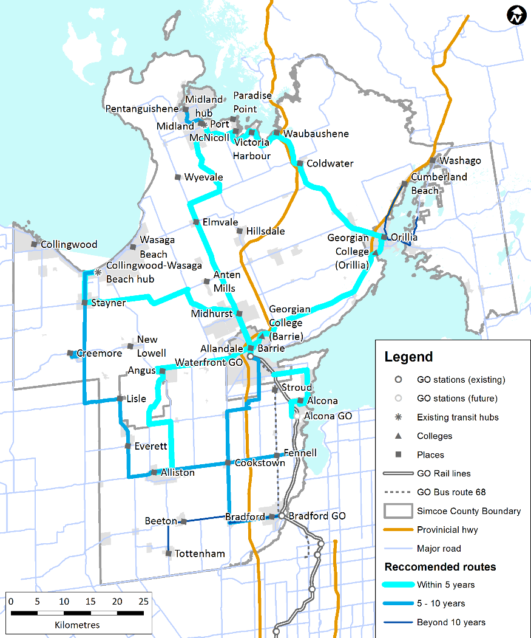

Each of the connections was assessed further based on its ability to promote county-wide network connectivity and incorporated considerations of planned development and projected build-out.

Evaluation criteria used to identify the merits of potential service connections also took into consideration a variety of indicators including ridership and fare revenue, cost, service, route connectivity, markets, broader County connectivity, and ease of operation and safety. As a result, the preliminary service prioritization for various routes were ranked correspondingly. The preliminary prioritization was presented during the second round of consultation and feedback.

The second round of public consultation was comprised of two public workshops, a stakeholder meeting, and an on-line questionnaire in November 2015. The public workshops were made available online via a live webcast. The purpose of the consultation was to seek feedback on proposed inter-municipal connections in the county and to identify connections that could be implemented within the next five years. Preliminary discussions introduced fare policy structures and funding approaches for the proposed inter-municipal transit system.

The study’s consultation process identified that participants thought the County’s principal role for transit is to provide longer-distance hub-to-hub areas, rather than the shorter distance intra-hub connections. In addition, as a result of participant feedback, refinements were made to the alignment of the preliminary proposed routes to reflect advisory team, stakeholder and public feedback received. The revisions to the proposed short-term integrated service network included an Alliston – Bradford route (as opposed to Alliston – Barrie route), as it would provide south Simcoe residents with more direct access to Central Local Health Integration Network (LHIN) health services. Another change was also made to the Midland – Barrie route to provide for a more direct route to the Royal Victoria Hospital and Georgian College campus via County Road 93 and to avoid duplication of service along County Road 27 of the proposed Wasaga Beach – Barrie route.

## Hubs and Route typologies

## Priority has been given to connecting regional primary settlement areas designated in the Growth Plan for the Greater Golden Horseshoe and in the County Official Plan. The majority of these primary areas were identified as “hubs” for purposes of the transit study. The hubs generally have their own local transit systems and are contiguous or near-contiguous urbanized areas. They also tend to be economically self-contained, so that a large proportion of trips already occur within the hub. However, there is a notable number of trips made between hubs, and it is these trips that are the consultant’s recommendation for County-level transit inter-municipal connections.

## The identified hubs are:

* Alliston
* Barrie
* Bradford
* Collingwood/Wasaga Beach
* Midland/Penetanguishene
* Orillia

The routes identified for short-term implementation are varied in length. To assist with developing the strategy Steer Davies Gleave established the following three different connection typologies:

* Inter-municipal connections: operate between hubs (such as Alliston – Bradford route)
* Intra-hub connections: operate within hubs that span multiple local municipalities (such as Midland/Penetanguishene)
* Barrie-Orillia connection: connects two distinct neighbouring municipal urban areas and provides connectivity with other County transit services.

Illustration of connection typologies

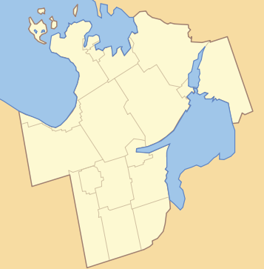

Connection Typologies

|  |  |
| --- | --- |
|  | Inter-municipal connections (long distance) |
|  | Intra-hub connections (short distance) |
|  | Barrie-Orillia connection |
|  | County hub areas |

**Midland/Penetanguishene**

**Collingwood/Wasaga Beach**

**Orillia**

**Bradford**

**Barrie**

**Alliston**

## Recommended short term service plan

## Based on feedback provided from the consultation process, as well as applying specific criteria using the multiple account evaluation (MAE) framework the short-term service plan was developed for implementation over a 5 year staged rollout.

## The proposed short term service plan includes five new inter-municipal hub-to-hub routes (prioritized 1 to 5). The illustration of the short term service plan shown herein also incorporates the various existing shorter intra-hub routes (lettered A to D below) currently provided by the local municipalities.

Proposed short term inter-municipal service plan

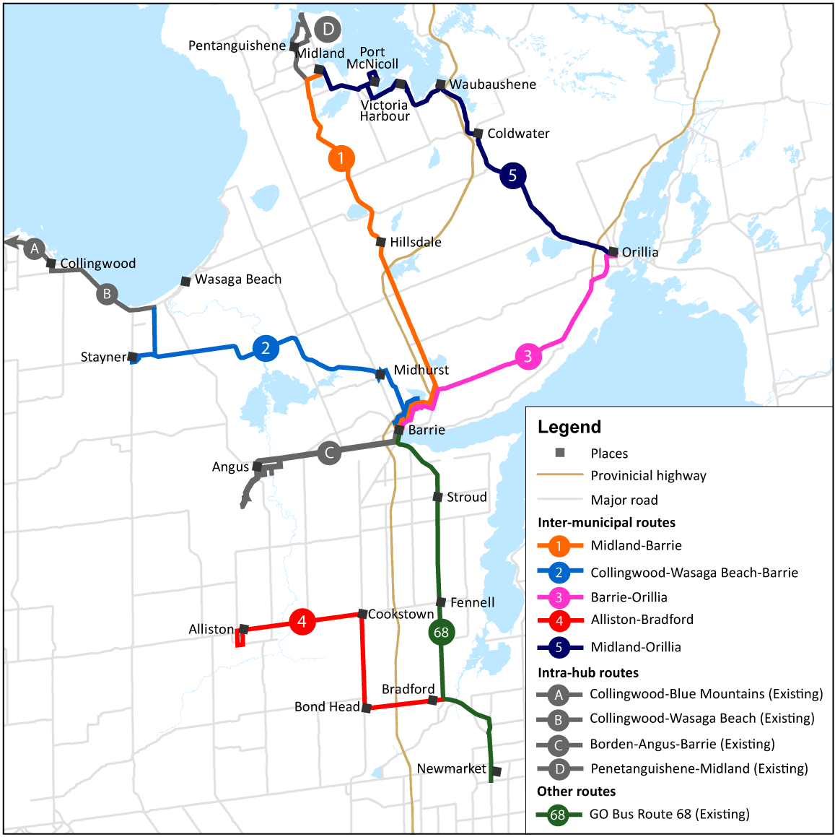

Specialized Transit AODA requirements

The situation for specialized transit in Simcoe County will be complex, given the presence of both the proposed inter-municipal and local transit services. As legislated by the *Accessibility for Ontarians with Disabilities Act* (AODA), there would need to be a coordinated parallel transit service accessible to residents who are unable to walk to the nearest bus stop because of a disability. The number of requirements for municipal transit service and the requirements for a specialized transit service to complement conventional transit will need to be taken into consideration when planning service stops and determining the costs of delivery.

A specialized transit service is required to provide origin to destination service. However, this does not require a direct service – passenger journeys may be accommodated using multiple trip legs. The service span would need to be the same as conventional transit, thus the need for a coordinated service. The operating costs are summarized in the Financial and Implementation Plan section below and include the combined cost of both conventional and specialized transit services within Simcoe County.

Fare Structure Framework

The fare structure for the proposed inter-municipal service needs to be both financially sustainable for the County and municipalities, and to encourage consistent ridership.

In consultation with stakeholders and public participants, the following principles of the proposed fares structure were developed:

|  |  |  |
| --- | --- | --- |
| Principle | Passenger Perspective | Operator/Municipal Perspective |
| Simple | Easy and logical for transit users to understand | Simple to implement, operate and manage |
| Affordable | Fare should be affordable for transit users | Fare should ensure appropriate operator cost effectiveness |
| Consistent | Fare structure should be consistent throughout the County | Fare structure should enable appropriate operator fare revenue recovery |

The proposed inter-municipal transit service fare structure framework connects the six recommended inter-municipal hubs. Some of the inter-municipal hubs provide connection to adjacent intra-municipal services, such as the existing Collingwood – Wasaga Beach link. Fare integration with existing transit services, based on the fare structure principles should be simple, affordable and consistent throughout the County. For these reasons, Steer Davies Gleave recommends a partial fare integration fare structure.

The recommended partial fare integration fare structure encourages integrated travel between transit systems. It is proposed to be affordable, as it discounts a continuous journey, thus allowing the rider to transfer onto the adjacent municipal transit system without having to pay a second full fare. It is also a benefit to the adjacent municipal transit provider because the operator acquired another customer it wouldn’t otherwise have. In addition, the recommended fare structure does not require fare reconciliation between operators. Each operator retains all fare revenue it collects.

For example, a customer travelling from their neighbourhood in Midland to the Royal Victoria Hospital (RVH) to visit a family member would take the local transit service and pay the $2 fare to reach the Midland – Barrie inter-municipal connection. With their transfer, the customer would receive a $1 discount and pay the $6 fare to RVH. Having completed the visit at the hospital, the customer would return to Midland on the inter-municipal route and pay the $7 inter-municipal fare. Once in Midland, the customer would transfer back onto the Midland transit, at no cost, to complete their journey. The return trip cost the customer $15, of which $2 was spent on the local service and $13 on the inter-municipal service. Because the customer was able to reach their destination, the local transit service acquired a paying customer at 50% the fare rate (as opposed to no customer at all).

Many partnering transit agencies in Ontario practice a form of fare integration. For example, Metrolinx has outlined in its ‘Discussion Paper for the Next Regional Transportation Plan’ (August 2016) the importance of an integrated fare system to reduce obstacles of seamless travel and “to support the development of transit services between municipalities”. The benefit of having a consistent travel experience for both the customer and the operator would encourage inter-municipal transit use.

Within Ontario, there are several public transit agencies that operate long-distance inter-municipal services. These fulfil a similar function to the proposed County inter-municipal services. Those services (and their adult cash fare) are:

* Muskoka Extended Transit – $3.00
* Niagara Region – $6.00
* Ride Norfolk – $6.00
* Deseronto Transit – $10.00

Considering comparable rates and participant feedback received, it is recommended that the inter-municipal adult cash fare (boarding cost) be $7 per trip, with a $1 discount for passengers transferring from another transit route. Pre-purchased tickets or period passes could be made available at lower price per trip. The proposed fare rate of $7 is striving to be affordable for all residents, however generates some revenue to contribute to the cost of service operations.

Funding Options

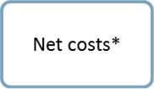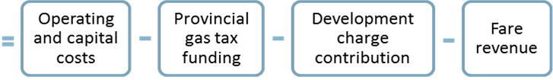

* Net costs will be the County’s responsibility.

Operating costs include service operations and maintenance, administration (staffing) and marketing. Capital costs include vehicles and bus stop infrastructure.

The Province of Ontario operates a program whereby a portion (2 cents per litre) of its gasoline tax revenues are given to municipalities operating transit, known as provincial gas tax funding. The amount provided is based on the number of trips on the transit system, and the population of the municipality it serves. However, despite whatever amount is generated based a specific formula, the total amount provided under the program is capped at 75 percent of municipal spending in the previous year.

The revised *Development Charges Act* allows the consideration of eligible growth-related capital transit expenditures based on planned levels of service projecting 10 years in the future. Transit is a relatively recent inclusion for consideration in development charges by-laws, for this reason development charge contributions have not been included in the financial plan at this time. However, the County could consider applying development charge contributions, in accordance with the *Development Charges Act* as an appropriate source of revenue.

Other potential funding opportunities such as the Federal Public Transit Infrastructure Fund (PTIF) and the provincial Greenhouse Gas Reduction Account may be made available to the County should the County pursue planning for multimodal transportation infrastructure and investments in transit.

Fare revenues are derived from the fare mechanism (boarding costs) and ridership levels.

Financial and Implementation Plan

As outlined in Item CCW 16-132 (March 22, 2016), two financial structures were presented:

* Delineated responsibilities: County pays 100% of the costs of inter-municipal routes; local municipalities providing intra-hub routes pay 100% of the costs of the intra-hub route,
* Shared responsibilities: Costs of inter-municipal routes and intra-hub routes are split equally 50%-50% between County and local municipalities providing intra-hub routes.

Steer Davies Gleave recommend the delineated responsibilities option as it would provide a clearer and more predictable structure for the County’s planning and financial responsibilities. The County would only be responsible (and fully responsible) for inter-municipal routes that connect between hubs, leaving intra-hub routes to be operated and funded by local municipalities (who would have a better understanding of the travel needs of its residents).

Under the shared responsibilities structure, any decisions made in relation to both intra-hub and inter-municipal transit services with financial consequences would require approval from the County and all the respective local municipalities contributing to the costs of the services. These decisions will include vehicle requirements, service span, frequency, routings, fares, and stop amenities. The need for approval from County and local municipalities may lead to challenges and delays in introducing new services and being responsive to changing travel needs.

The financial plan summary provided by the consultants is intended to offer a snapshot of the average costs for transit services in Simcoe County. The capital costs summarized in Interim Report 3 have been annualized whereby the cost of each item has been divided by its typical lifespan.

In addition, staff have prepared a financial plan, implementation details and alternative funding options (Schedule 2) structured in a 10 year financial outlook format using actual costs (not annualized) and data compiled by the consultants including the following inter-municipal service assumptions:

* + 252 Days operated per year (Mon-Fri, excluding holidays)
  + 12 Hours of service per weekday
  + $100 Operating cost per service hour ($) (includes operation of parallel specialized transit)

Option 1 A – Inter-municipal routes excluding Barrie - Orillia route: County pays 100% of the costs of inter-municipal routes, excluding the Barrie-Orillia route; local municipalities pays 100% of the costs of the intra-hub route,

Option 1 B – Inter-municipal routes including Barrie - Orillia route: County pays 100% of the costs of inter-municipal routes, and 33.3% of the costs of the Barrie-Orillia route; local municipalities pays 100% of the costs of the intra-hub route,

Option 2 A - Inter-municipal and intra-hub routes excluding Barrie - Orillia route: County pays 100% of the costs of both the inter-municipal and intra-hub routes,

Option 2 B - Inter-municipal and intra-hub routes including Barrie - Orillia route: County pays 100% of the costs of both the inter-municipal and intra-hub routes, and 33.3% of the costs of the Barrie-Orillia route.

County staff have used data compiled by Steer Davies Gleave to provide additional information regarding financial plan options and implementation details in consideration of funding 100% of the existing intra-hub routes (specifically routes lettered B, C, D). The existing intra-hub Blue Mountain – Collingwood route (A) would require a second intra-hub connection (the Collingwood – Wasaga Beach intra-hub route) to connect to the proposed longer distance inter-municipal connection. In addition, the Blue Mountain – Collingwood intra-hub route extends beyond the jurisdiction of the County. For these reasons, the existing intra-hub routes completely within the County are considered for funding in the additional financial plan options 2A and 2B at this time. Criteria would be required to be established prior to consideration of additional intra-hub connections.

The proposed Barrie-Orillia route has significant benefits to municipalities outside of Simcoe County (namely, Barrie and Orillia), however the proposed route scored high in the preliminary route evaluation as it would also support the broader economic, environmental and social objectives of development within Simcoe County. The financial structure for the Barrie-Orillia route connection requires special financial consideration prior to implementation given the cities are not within the jurisdiction of the County. The 10 year financial plan prepared by staff assumes the County would be responsible for a third of the costs.

Given the principal focus of providing longer-distance hub-to-hub connections was identified as a priority in the consultation process, Steer Davies Gleave identified two potential approaches for implementation of the proposed inter-municipal routes:

* Full implementation of all proposed inter-municipal routes, with a minimal number of daily trips for each route, or
* Staged rollout of proposed inter-municipal routes, with a higher number of daily trips for each connection.

## Staff recommend implementing a County transit service plan in a staged rollout. Phased implementation would allow the County to spread the start-up costs over multiple years. Any lessons learned from implementing the initial phases can be applied to later phases, maximizing the success of the implementation.

## It is recommended higher-priority routes be implemented in earlier phases and low-priority routes be implemented in later phases. Based on the staged approach, County staff have laid out a 10 year financial outlook phasing in costs of routes in years 1 to 4.

A phased approach would provide a more appropriate level of transit service that passengers can depend on. The full implementation approach (with minimal number of daily trips) may lead the service to be spread too thinly to attract consistent ridership.

Next Steps

Contingent on the funding option preferred by County Council, future steps for implementing a transit service in the short term (next five years) would generally include the following:

* County Council approval of a select transit service and preliminary financial plan
* County Council approval of budget
* Allocate staffing to support service
* Determine operating model (in-house/private contractor/public contractor)
* Vehicle procurement
* Develop a marketing plan
* Plan and construct infrastructure requirements
* Launch service
* Monitor and report on the performance of the service on an on-going basis

It is recommended potential refinements of the service plan be evaluated at the next stage of work prior to developing and implementing detailed service designs for the connections identified within the 5-10 year timeline.

**Financial and Resource Implications**

The costs associated to complete the Transit Feasibility and Implementation Study are included in the 2016 budget.

Future financial or resources implications associated with this Item will be determined following direction from County Council and will be brought forth in appropriate annual budgets and long-term financial plans for Council approval.

**Relationship to Corporate Strategic Plan**

Growth Related Service Delivery: Create and strengthen partnerships with key stakeholders to support communities through the delivery of sustainable services.

**Reference Documents**

* Item CCW14-269 (June 3, 2014) County of Simcoe Transit Initiatives
* Item CCW14-285 (June 24, 2014) County of Simcoe Transit Feasibility and Implementation Study
* Item CCW15-149 (April 28, 2015) County-wide Transit Feasibility and Implementation Study
* Item CCW15-320 (September 22, 2015) County Transit Feasibility and Implementation Study – Interim Report 2
* Item CCW16-132 (March 22, 2016) County Transit Feasibility and Implementation Study - Update

**Attachments**

Schedule 1 – Interim Report 3



Schedule 2 – Alternative Financial Plan – 10 Year outlook



**Prepared By:** Rachelle Hamelin, MCIP,RPP, Planner III

**Approvals: Date**

|  |  |
| --- | --- |
| David Parks, Director of Planning, Development and Tourism | August 24, 2016 |
| Debbie Korolnek, General Manager, Engineering, Planning and Environment | August 25, 2016 |
| Trevor Wilcox, General Manager, Corporate Performance | August 29, 2016 |
| Mark Aitken, Chief Administrative Officer | August 30, 2016 |
|  |  |